Senate Hearing 15 February 2018
Mr Chair, members of the standing senate committee on fisheries and oceans, thank you for the opportunity to appear as a witness on the matter of search and rescue in the arctic where the challenges and opportunities are greatest.
Challenges
many of you know the challenges well.
The size of the canadian arctic and distances to sar resources are great and they are compounded by weather.
You will see in the supporting documentation a map that shows that the canadian arctic is larger than continental Europe.
Another IMAGE HIGHLIGHTS the fact that part of Canada’s sar responsibility under the Arctic Council AGREEMENT ON COOPERATION ON AERONAUTICAL AND MARITIME SEARCH AND RESCUE IN THE ARCTIC includes the north pole which is 4,463 km from SAR aircraft based in Winnipeg. It is the equivalent of STATIONING the SAR assets of Newfoundland in Frankfurt Germany.
yet, there are no Major SAR assets in the arctic. they are too far south requiring a transit time that is too long for an area where time is critical.
Increasing maritime traffic made possible by the accelerating loss of arctic sea ice has led to some 178 vessels making a total of over 406 visits to the arctic including 32 northwest passage transits in 2017 alone.
i have also raised concerns with our Aging coast Guard icebreaker fleet on several OCCASIONS; all of our icebreakers are reaching the end of their design life and increasing demand for icebreaker support is leaving the fleet STRETCHED.
One of the challenges in the Arctic is acting fast enough because of the cold weather. If we were to have a Costa Concordia accident in the arctic the PASSENGERS that would jump, unprotected, in the frigid waters would be dead in minutes while SAR aircraft would be hours away and Coast guard vessels could be days away.
Northern people expect and deserve more. They should not be forced to accept a much lower quality of federal services.
Arctic Maritime accidents are not a theoretical exercise. Two cruise ships and one tanker have already run aground. Note the statistics in the supporting pages.
unfortunately the deployment of sar assets is based on historical facts rather than anticipated activity.
Former Prime minister stephen harper, during one of his trips to the arctic, stated that Canada could not provide the same level of SAR service in the arctic as in the south. that is true, but I say that we can certainly do better than what we have now.
Opportunities
There are several opportunities to do better and i’d like to name a few.
all SAR air assets should be equipped with forward looking infrared radars such as the new SAR fixed wing aircraft will have. It will make SEARCHING for survivors and vessels that much easier and faster against the cold water background.
Canada has been investing in the arctic CCG Auxiliary and this will increase SAR assets but that investment needs to be long-term.
For a number of years it has been recommended, including by your own committee, to provide the Canadian RANGERS WITH a Maritime role. They could increase our Sar capabilities but also act as first responders to report illegal fishing, initiate action on marine spills and provide a SOVEREIGNTY presence throughout the arctic. who could CRITICIZE the inuit for doing SO? they would reinforce our SOVEREIGNTY position over the internal waters of the arctic archipelago.
Resolute Bay could be further developed as a contingency facility that would increase our capacity to deal with a major accident for the recovery and extraction of survivors and to deal with the environmental impact. (article attached)
THE US Coast Guard positions helicopters in alaska during shipping season. We could do something similar. It has been recommended to position air SAR assets in Yellowknife to reduce the transit time to the arctic. Those assets could also be deployed south if need be.
The new arctic offshore patrol ships will soon increase the SAR capabilities. they will need to deploy there during the shipping season.
One of the most cost effective actions canada could take will be to direct preventive measures that will reduce the likelihood of expensive accident recovery and environmental impact such as:
Making reporting to NORDREG compulsory for all vessels over 30 tons and above, all vessels carrying paying passengers and all ships carrying dangerous cargos.
similarly Require all such vessels to be equipped with automatic identification systems. Those can be monitored from space.
both measures will improve our arctic domain awareness, a stated federal PRIORITY.
Enforcing the new polar code and requesting even higher standards of the International Maritime Organisation.
Completing the selection of arctic marine corridors and making those compulsory. Map those corridors to modern standards and provide them with navigational aids.
ensure that the obsolete search and rescue mission management SYSTEM is replaced with a modern system in a timely fashion.
consider the use of drones as a cost effective option to support local SAR.
increase funding for civil air search and rescue association in the arctic.
and consider contracting civil aviation to provide Arctic sar similar to the service provided by COUGAR aviation to the oil and gas industry.
all of the above recommendations are well supported by policies and many echo your own Senate recommendations of 2009 and 2011.

Arctic region
 | 2002 | 2003 | 2004 | 2005 | 2006 | 2007 | 2008 | 2009 | 2010 | 2011 | 2012 | 2013 | Average
Shipping accidents | 2 | 7 | 6 | 0 | 4 | 3 | 5 | 6 | 5 | 1 | 6 | 6 | 4.3
Accidents aboard ship | 0 | 5 | 1 | 0 | 3 | 1 | 1 | 0 | 0 | 0 | 2 | 2 | 1.3
Vessels involved in shipping accidents | 2 | 7 | 8 | 0 | 4 | 4 | 5 | 6 | 5 | 1 | 7 | 8 | 4.8
Cargo | 0 | 3 | 0 | 0 | 0 | 0 | 1 | 0 | 0 | 0 | 1 | 0 | 0.4
Bulk carrier/Ore-bulk-oil (OBO) carrier | 0 | 0 | 0 | 0 | 0 | 0 | 0 | 0 | 0 | 0 | 0 | 0 | 0.0
Tanker | 0 | 1 | 1 | 0 | 0 | 1 | 0 | 0 | 3 | 0 | 2 | 0 | 0.7
Ferry/Passenger | 0 | 0 | 0 | 0 | 2 | 0 | 0 | 0 | 1 | 0 | 1 | 0 | 0.3
Tug/Barge | 2 | 0 | 2 | 0 | 1 | 0 | 2 | 3 | 0 | 0 | 3 | 8 | 1.8
Fishing | 0 | 0 | 0 | 0 | 0 | 0 | 1 | 0 | 0 | 0 | 0 | 0 | 0.1
Other | 0 | 3 | 5 | 0 | 1 | 3 | 1 | 3 | 1 | 1 | 0 | 0 | 1.5
Vessels lost | 1 | 0 | 0 | 0 | 1 | 0 | 0 | 1 | 1 | 0 | 0 | 0 | 0.3
Fatalities | 0 | 2 | 1 | 0 | 1 | 1 | 0 | 0 | 0 | 0 | 0 | 0 | 0.4
Incidents | 1 | 1 | 5 | 0 | 2 | 0 | 2 | 2 | 3 | 1 | 6 | 0 | 1.9
Sum | 8 | 29 | 29 | 0 | 19 | 13 | 18 | 21 | 19 | 4 | 28 | 24
Supporting Material
Maritime Accidents

Note: Statistics for year past 2013 make it impossible to easily segregate the territories information. The data is now presented for Pacific, Central and Atlantic Regions.
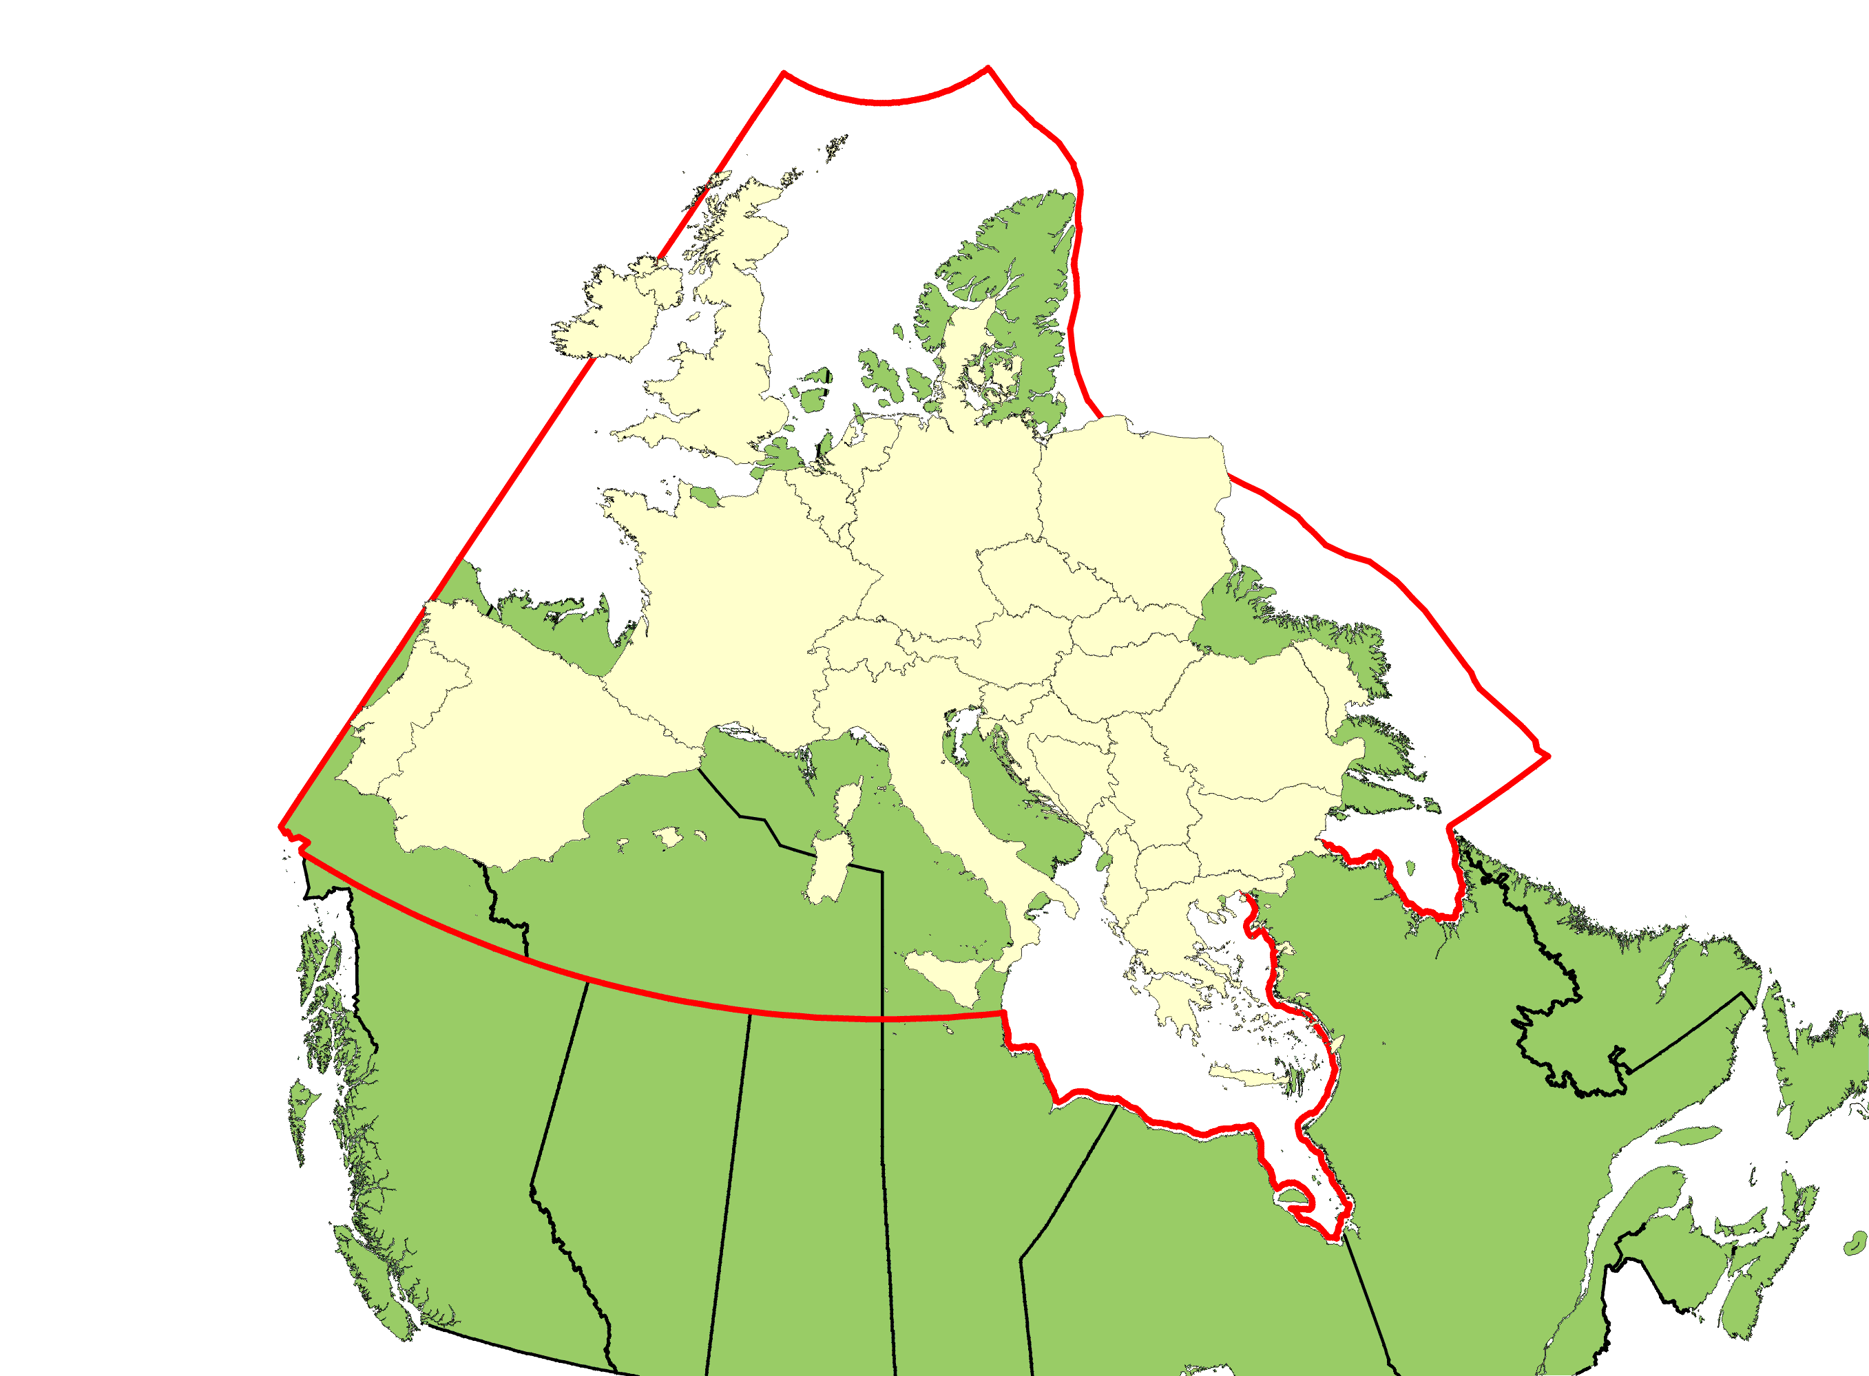
The area of the Canadian Arctic is larger than continental Europe
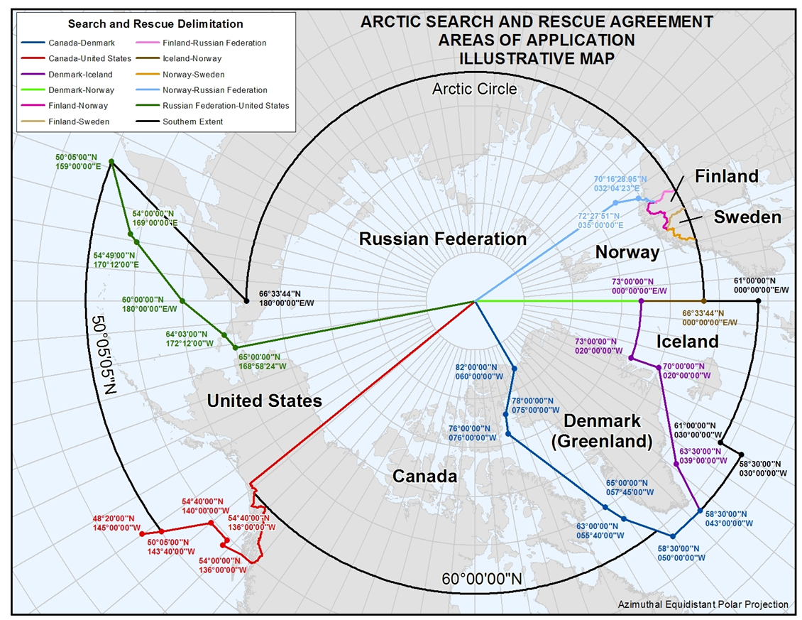
AGREEMENT ON COOPERATION ON AERONAUTICAL AND MARITIME SEARCH AND RESCUE IN THE ARCTIC
This image shows the area of responsibility of Canada for arctic SAR as per the agreement

